Supplementary Materials

Supplementary Table 1. Complete parameter dictionary.
Parameter | Value | Source | Range used in sensitivity analysis
Decision Tree Probabilities
Population size | 1,299,708 | CDC 2022 | Not varied
P(willing to use ARV PrEP) | 0.6 | CDC | Beta, 0.40 to 0.79
P(oral PrEP &#124; willing) | 0.7 | Assumption | Beta, 0.60 to 0.79
P(brand &#124; oral) | 0.5 | Assumption | Beta, 0.40 to 0.60
P(bnAb &#124; non-oral) | 0.2 | Assumption | Beta, 0.11 to 0.31
P(monthly &#124; injectable) | 0.8 | Assumption | Beta, 0.69 to 0.89
P(bnAb &#124; not willing) | 0.1 | Assumption | Beta, 0.06 to 0.15
P(switch oral to bnAb) | 0.05 | Assumption | Beta, 0.03 to 0.08
Timeline
Year of FDA approval | 2030 | Projection | Not varied probabilistically; 2033 in scenario S3
Years trial to approval | 5 | Projection | Not varied
Forecasting
PrEP annual growth rate | 8% | Historical trend | Gamma, 6.5% to 9.7%
Doses per user per year | 1.7 | Assumption | Gamma, 1.37 to 2.06
Annual Costs to US Payer
Branded oral PrEP cost/yr | $16,600 | WAC | Not varied
Generic oral PrEP cost/yr | $8,300 | WAC | Not varied
Every 2 months injectable cost/yr (CAB-LA) | $25,800 | WAC | Not varied probabilistically; $18,060 in scenario S1
Every 6 months injectable cost/yr (LEN) | $28,218 | WAC | Not varied probabilistically; $19,753 in scenario S1
bnAb cost/yr | $14,000 | WAC | Derived as 2.0 doses × US WAC/dose; $11,370 to $16,951
Wholesale Acquisition Cost bnAbs by Country
WAC/dose (US) | $7,000 | WAC | Gamma, $5,685 to $8,475
WAC/dose (France) | $3,000 | Tiered pricing | Scaled with US price; $2,436 to $3,632
Manufacturing Costs bnAbs
Fixed cost: trial mfg | $10,000,000 | Manufacturer estimate | Not varied
Fixed cost: launch mfg | $50,000,000 | Manufacturer estimate | Not varied
Marginal cost/dose | $195 | Calculated | Not varied
Cost per gram | $50 | Industry estimate | Not varied
Grams per dose | 3 | Dosing regimen | Not varied
Packaging markup | 30% | Industry estimate | Not varied
Discounting
Discount rate, annual | 3% | Standard practice | Scaled Beta, 0.6% to 4.9% (0% to 5% support)
Present-value reference year | 2030 | Year of assumed approval | Not varied

Supplementary Table 2 United States annual bnAb supply model detail (post-approval). All figures in this table are nominal. Discounted totals are reported in Table 2 of the main article.
Year | PrEP Users | bnAb Share | bnAb Clients | Doses | Revenue | Prod. Cost | Net Revenue
2030 | 707,550 | 1.25% | 8,866 | 15,073 | $105.5M | $2.9M | $102.6M
2031 | 764,154 | 4.18% | 31,919 | 54,263 | $379.8M | $10.6M | $369.3M
2032 | 825,286 | 8.35% | 68,946 | 117,208 | $820.5M | $22.9M | $797.6M
2033 | 891,309 | 12.5% | 111,692 | 189,877 | $1,329.1M | $37.0M | $1,292.1M
2034 | 962,613 | 12.5% | 120,627 | 205,067 | $1,435.5M | $40.0M | $1,395.5M
2035 | 1,039,622 | 12.5% | 130,278 | 221,472 | $1,550.3M | $43.2M | $1,507.1M
2036 | 1,122,792 | 12.5% | 140,700 | 239,190 | $1,674.3M | $46.6M | $1,627.7M
2037 | 1,200,000 | 12.5% | 150,375 | 255,638 | $1,789.5M | $49.8M | $1,739.6M
2038 | 1,200,000 | 12.5% | 150,375 | 255,638 | $1,789.5M | $49.8M | $1,739.6M
2039 | 1,200,000 | 12.5% | 150,375 | 255,638 | $1,789.5M | $49.8M | $1,739.6M
2040 | 1,200,000 | 12.5% | 150,375 | 255,638 | $1,789.5M | $49.8M | $1,739.6M
Note: WAC per dose: $7,000. Marginal manufacturing cost: $195/dose.

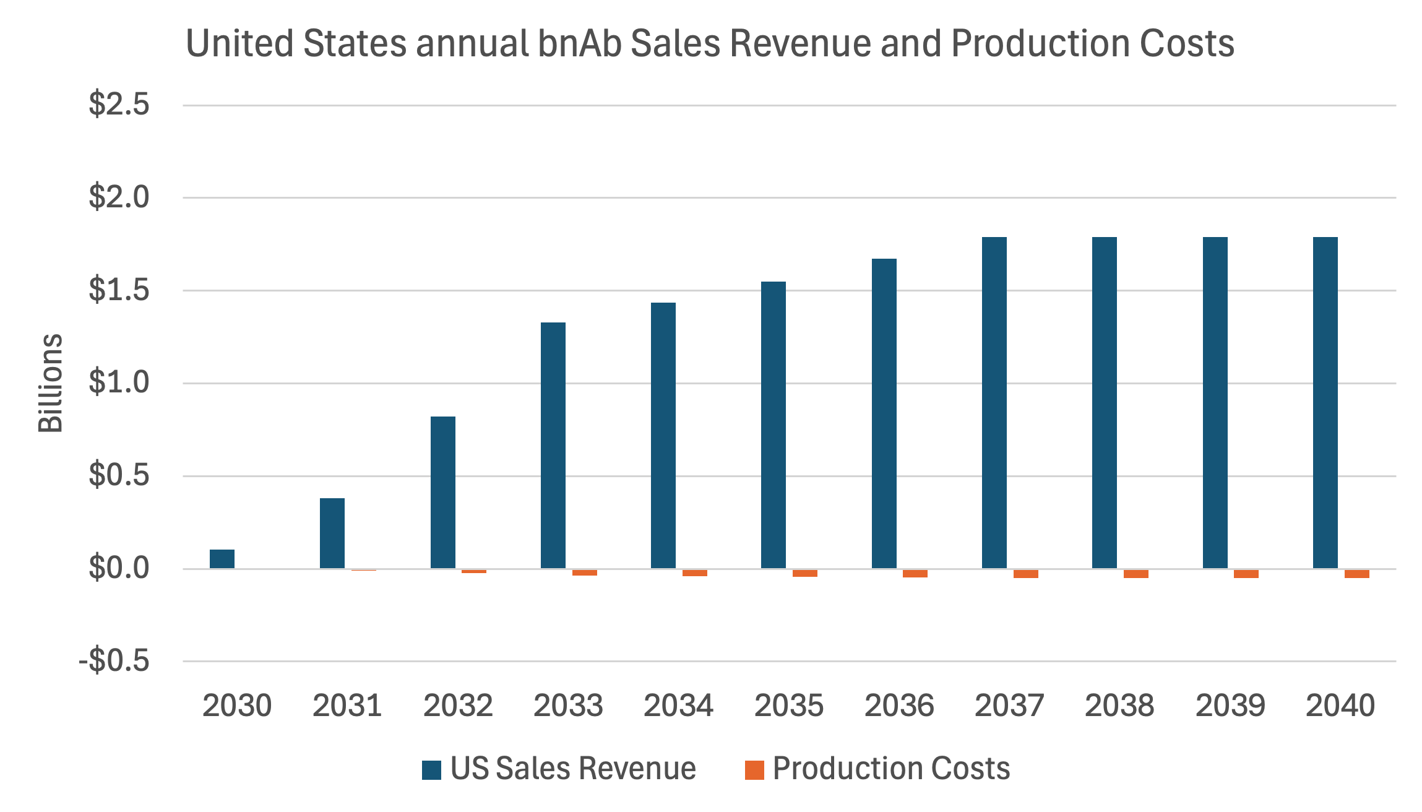
Supplementary Figure 1: US sales revenue and production costs (2030-2040). Figures are nominal.

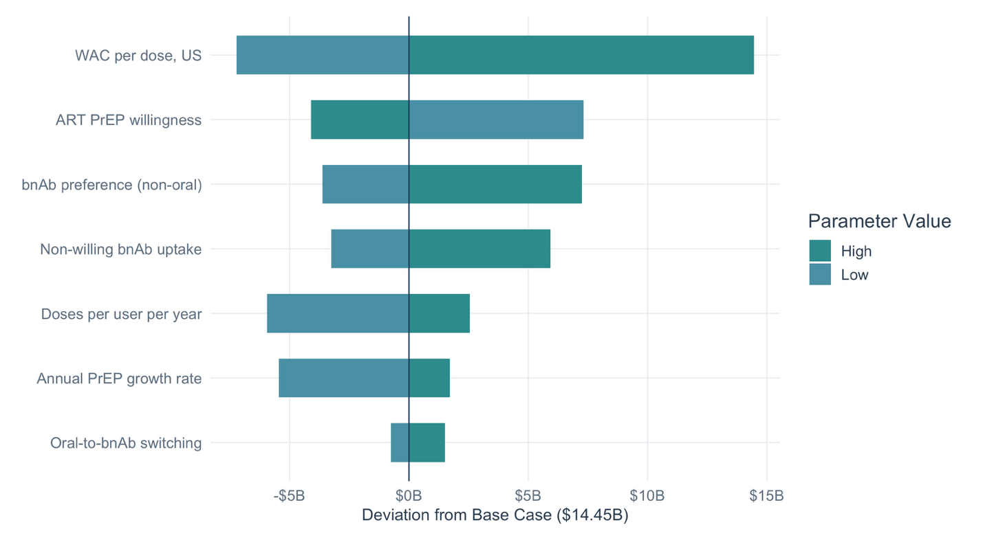
Supplementary Figure 2. Tornado diagram: one-way sensitivity of US total revenue (2022–2040) to key model parameters. Bars show deviation from base-case revenue. Parameters are ordered by influence (largest range at top). Revenue in this figure is nominal; the base case of the main article is discounted at 3% per year to 2030.

Supplementary Table 3. One-way sensitivity analysis: US total revenue (2022–2040). Revenue in this one-way analysis is nominal; the base case of the main article is discounted at 3% per year to 2030.
Parameter | Low | Base | High | Revenue (Low) | Revenue (High) | Range
WAC per dose, US | $3500 | $7000 | $14,000 | $7.23B | $28.91B | $21.68B
ARV PrEP willingness | 0.40 | 0.60 | 0.80 | $21.76B | $10.35B | $11.41B
bnAb preference (non-oral) | 0.10 | 0.20 | 0.40 | $10.83B | $21.70B | $10.87B
Non-willing bnAb uptake | 0.05 | 0.10 | 0.20 | $11.20B | $20.39B | $9.19B
Doses per user per year | 1.00 | 1.70 | 2.0 | $8.50B | $17.00B | $8.50B
Annual PrEP growth rate | 0.04 | 0.08 | 0.12 | $9.00B | $16.16B | $7.17B
Oral-to-bnAb switching | 0.00 | 0.05 | 0.15 | $13.70B | $15.97B | $2.27B
Note: Each parameter varied independently while holding all others at base-case values.

